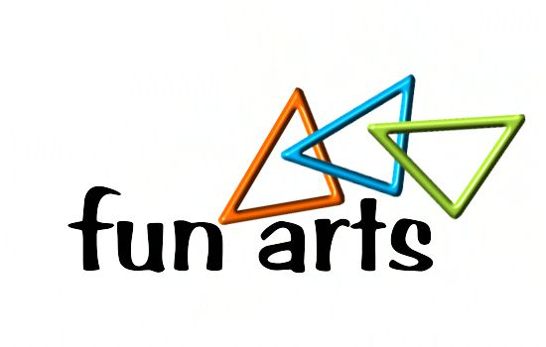

2019 Kids Fun Arts Festival Individual Registration Form
Phone Number ______________________ Grade _____________ Male or Female
Last Name__________________________ First Name ___________________________
Address__________________________ City/State/Zip ___________________________

Church Name________________________________
Cost: Each Category
District use only:
Date Rec'd: / /
Amount: $ Amount Owed: $

Student's Signature__________________________
Parent's Signature_____________________________
Children Pastor's Signature__________________________________

Categories (circle all that apply)
*NEW CATEGORIES
Music Division

Female Vocal Solo

Male Vocal Solo

Instrumental String Solo

Instrumental Wind Solo

Keyboard Solo

*Creative Movement Solo

*Children’s Worship Leading by Motions Solo

Drama Division

Human Video Solo

Drama Solo

Art Division

Painting

Drawing

Sculpture/3-dimensional

Photography

Puppetry

Puppetry Solo

Writings

Short Story

Poetry

Bible Memorization

Bible Memorization Solo

Bible Story Telling

Bible Story Telling Solo

*Object Lesson/Illustration

Object Lesson/Illustration Solo

Mission Country Display

Mission Country Display

Sign Language

Sign Language Solo

2019 Kid's Fun Arts Festival Group Registration Form
Church Name _________________________ Leader’s Name ___________________________
Address ____________________________ City, State, Zip ______________________________
Phone Number __________________________

Categories (circle all that apply)
*NEW CATEGORIES
Music Division
Vocal Ensemble Small Group (2-4 participants) Vocal Ensemble Large Group(4-10 participants)

Instrumental Small Group (2-4 participants) Instrumental Large Group (4-10 participants)

*Creative Movement Group (2-10 participants)

*Children’s Worship Leading by Motions Group (2-10 participants)

Drama Division
Human Video Small Group (2-4 participants) Human Video Large Group (4-10 participants)

Drama Small Group (2-4 participants) Drama Large Group (4-10 participants)

Puppetry
Puppetry Group (2-10 participants)

Sign Language
Sign Language Group (2-10 participants)

